RESQAI: AI-BASED ACCIDENT DETECTION, SEVERITY ASSESSMENT AND INTELLIGENT EMERGENCY RESPONSE SYSTEM
Methodology, Novelty and Key Contributions
Department of Computer Science and Engineering, TKR College of Engineering & Technology
Batch A2 (CSE-A) · Academic year [ACADEMIC YEAR]
Table 1: Project team
S.No. | Student name | Roll number
1 | Adepu Meenakshi | 23K91A0503
2 | Ayila Shanmukha Sai | 23K91A0521
3 | Chekka Chandrashekhar | 23K91A0552
4 | Avula Sreeya | 23K91A0519

Project guide: Shirisha Reddy
Chapter and section numbers quoted in the text (for example Chapter 8 or Section 6.2) refer to the full project report, 17.Final Document. Figures and tables in this document are numbered from 1.

1. METHODOLOGY
This document describes how ResQAI works from end to end and what is new in it. Part 1 gives the pipeline, the data, the algorithms and the reasons they were chosen; Part 2 sets the work against the base paper and separates what is new from what is standard; Part 3 lists the contributions. All figures quoted come from the measurements made for this report on synthetic data and are not claims about real roads.

1.1 Overall Methodology
The method has two halves. The first half is what the product does: a reading of eleven features is classified as crash or not, graded, confirmed by the occupant and turned into a located alert. The second half is how the claims about it were checked, because the project shipped without any evaluation: no metrics file existed, so every number in this report was measured afresh by three scripts written for the purpose. The method, in order, is:
1. Define the event and the features. A crash is a short, large acceleration and rotation spike with a speed drop; harsh braking and normal driving are the look-alikes. Eleven features describe an event (Table below).
2. Generate the data. train_models.py draws 12,000 synthetic events of five kinds with a fixed seed (42); there are no real recordings.
3. Split and scale. An 80/20 split stratified on the accident label gives 9,600 training and 2,400 test events; a StandardScaler is fitted on the training part only.
4. Train two random forests. One predicts accident / no accident, the other predicts the four-level severity; both use balanced class weights.
5. Serve them. app.py loads the pickles once, builds the feature vector of each request, applies the detector-gates-severity rule and returns the label, the probability and the features used.
6. Confirm and dispatch. The browser opens a 15-second countdown for Moderate and Severe results; on expiry it reads the position, ranks the hospitals by great-circle distance and composes the dispatch message.
7. Measure. The shipped pickles are scored on the held-out 2,400 events and compared with a fresh retrain; a five-seed repeat, four baselines, feature ablations, a noise sweep, a threshold sweep and two out-of-distribution probes follow; the API is timed and 55 unit, edge-case and security checks are run.
The base paper follows a different method for a different problem: it trains a multi-task FT-Transformer with an uncertainty-weighted loss on 30,442 police-reported crash records to predict injury, fatality and property-loss severity after the event [1]. ResQAI shares only the idea of grading severity; its input is a motion-sensor reading, its output is an alert decision, and its models are far smaller (Section 6.4).

1.2 Dataset
Source and licence. The dataset is generated by make_event and generate_dataset in train_models.py; it is self-made, has no external source and no licence restriction. Re-running the generator with numpy.random.seed(42) reproduces the same 12,000 rows, which the measurement script verified. The README describes the data as "crafted to resemble the documented sensor characteristics of real crashes"; this report treats it as exactly what it is, synthetic data whose classes were defined by the author of the generator. No smartphone recording, vehicle log or public crash-sensor corpus was used, so the first objective (collect smartphone data) is met only in the sense of a generator for the features.
Composition. Events are drawn from five kinds with probabilities 0.60, 0.20, 0.10, 0.06 and 0.04. Of the 12,000 rows, 19.89% are crashes. The accident label is 1 for the three crash kinds; the severity label is 0 for normal driving and harsh braking and 1, 2 and 3 for the three crash kinds.
Table 2: Composition of the synthetic dataset
Event kind | Events | Share | In the test split | Severity label
normal driving | 7,289 | 60.7% | 1,463 | 0 (None)
harsh braking | 2,324 | 19.4% | 460 | 0 (None)
minor crash | 1,215 | 10.1% | 233 | 1 (Minor)
moderate crash | 725 | 6.0% | 156 | 2 (Moderate)
severe crash | 447 | 3.7% | 88 | 3 (Severe)

Generator parameters. Every channel of every kind is drawn from a normal or uniform distribution (Table below). A crash spike has a magnitude drawn uniformly from a band that depends on the grade (15 to 28, 28 to 45, 45 to 80 m/s²) and a random direction in the horizontal plane, so that acc_x = m cos θ + noise and acc_y = m sin θ + noise; the vertical axis stays near gravity (9.81 m/s²) with a larger spread for harder crashes. Deceleration, rotation noise and jerk all grow with severity.
Table 3: Generator parameters per event kind (g = 9.81 m/s²; N = normal, U = uniform)
Channel | Normal driving | Harsh braking | Minor crash | Moderate crash | Severe crash
acc x, y (m/s²) | N(0, 0.4) | x N(-4.5, 1.2); y N(0, 0.6) | m cos θ, m sin θ, m ~ U(15, 28), noise 1.5 | m ~ U(28, 45), noise 2 | m ~ U(45, 80), noise 3
acc z (m/s²) | N(g, 0.3) | N(g, 0.5) | N(g, 2.0) | N(g, 3.0) | N(g, 5.0)
gyro x, y, z (rad/s) | N(0, 0.15) | N(0, 0.3) / 0.3 / 0.4 | N(0, 1.5) | N(0, 2.5) | N(0, 4.0)
speed before (km/h) | U(0, 80) | U(20, 100) | U(10, 60) | U(30, 90) | U(40, 140)
speed change (km/h) | N(0, 2) | -U(10, 35) | -U(10, 40) | -U(25, 55) | -U(45, 100)
jerk (absolute) | N(0, 0.5) | N(6, 2) | N(20, 5) | N(35, 8) | N(60, 12)

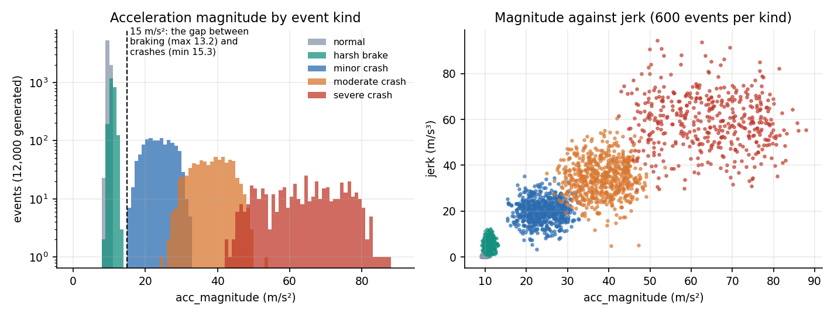
Figure 1: Distribution of acceleration magnitude by event kind (log scale) and magnitude against jerk: crashes sit well clear of harsh braking.
What the figure shows. Normal driving and harsh braking never exceed 13.2 m/s² in acceleration magnitude, whereas the weakest crash starts at 15.3 m/s²: a single threshold near 15 m/s² separates crash from non-crash with no error. The severity bands overlap only at their edges (minor and moderate between 24.9 and 32.8 m/s², moderate and severe between 42.4 and 53.6). This construction explains the near-perfect scores reported in Chapter 8 and is the most important thing to remember when reading them.
Split. train_test_split(test_size=0.2, random_state=42, stratify=accident) gives 9,600 training and 2,400 test events, of which 477 are crashes in the test part (233 minor, 156 moderate, 88 severe). There is no separate validation set and no cross-validation in the shipped script; the five-seed repeat of Chapter 8 compensates by regenerating the data and the split five times.
Contrast with the base paper. The base paper's data are proprietary police-reported records from one Chinese city (Dongguan, 2019 to 2023): 30,442 crashes split 19,483 / 4,871 / 6,088, with driver, vehicle, road and environment attributes and three severity targets [1]. The two datasets differ in origin (real versus generated), unit (a recorded crash versus a sensor event), features and labels, so no score on one can be compared with a score on the other.

1.3 Features and Preprocessing
A reading carries nine raw channels; two magnitudes are derived and the jerk is made non-negative, giving eleven features in a fixed order that is stored in feature_names.pkl so that training and serving can never disagree on column order.
Table 4: The eleven features
No. | Feature | Unit | Meaning | Raw or derived
1-3 | acc_x, acc_y, acc_z | m/s² | accelerometer axes; acc_z is about 9.81 at rest | raw
4 | acc_magnitude | m/s² | length of the acceleration vector | derived (or supplied by the client)
5-7 | gyro_x, gyro_y, gyro_z | rad/s | gyroscope axes (angular velocity) | raw
8 | gyro_magnitude | rad/s | length of the angular-velocity vector | derived (or supplied)
9 | speed_before | km/h | speed before the event (GPS) | raw
10 | speed_change | km/h | change in speed over the event; negative = slowing | raw
11 | jerk | not stated in code | rate of change of acceleration | raw, absolute value taken

Steps applied to every request (build_feature_vector): each field is read as a float; a missing acc_z defaults to 9.81 and every other missing field to 0, so an empty payload becomes a calm, stationary reading; acc_magnitude and gyro_magnitude are computed when the client does not supply them; jerk is replaced by its absolute value; and the values are arranged in the stored order. The React manual form sends the three accelerations, the gyroscope magnitude (carried on gyro_z, with gyro_x and gyro_y set to zero) and the three motion fields, and computes acc_magnitude itself.
Scaling. A StandardScaler is fitted on the 9,600 training rows and applied unchanged to the test rows and to every request, so that the test and serving data cannot influence the statistics. Random forests do not need scaling, and the scaler does not change their splits; it is kept because the pickled models were trained on scaled inputs and because it lets the logistic-regression baseline run on the same matrix.
Class imbalance. About one event in five is a crash and one in twenty is Severe or Moderate. Instead of resampling, both forests use class_weight='balanced', which weights each class by the inverse of its frequency. The base paper instead applies SMOTE with one neighbour to the training part [1, 23]; the two approaches have the same aim, and on this separable data the difference would not be measurable.
What is not done. There is no outlier clipping, no missing-value imputation beyond the defaults, no filtering of a raw accelerometer trace and no windowing: a reading is already a summary of an event. Turning a stream of raw 50 Hz samples into these summaries, and deciding when an event begins, is a necessary stage of a real smartphone application that this project did not build (Chapter 10).

1.4 Algorithm Choice and Justification
What was chosen. Two random forests [21] trained with scikit-learn [22]: a detector with 200 trees of depth at most 10 and a severity model with 250 trees of depth at most 12. A random forest averages many decision trees, each grown on a bootstrap sample with a random subset of features at every split; it handles features on different scales, captures interactions such as large acceleration and large speed drop, gives a probability that is used as the confidence, and exposes feature importances.
Why not a deep model. The base paper's FT-Transformer turns every feature into a token and applies self-attention [19], and weights its three tasks with learned uncertainties [20]. That machinery pays off on tens of thousands of heterogeneous, categorical-rich crash records. Here the input is eleven numeric channels with a clear physical meaning, the dataset is generated, and the deployment target is a phone or a small server; a transformer would add training cost, a larger artefact and a dependency on a deep-learning runtime without a measurable gain. The multi-task idea is kept in a simpler form: two models that share one scaler and one feature vector, joined by the gate.
What the comparison shows. To test whether the choice is justified, four alternatives were trained on the same split with the same scaled features. For the severity rows the detector gate is applied to every model, as in the application.
Table 5: Random forest against simpler models on the 2,400 held-out events
Model | Detector accuracy | Detector F1 | False alarms | Severity accuracy | Severity macro-F1
Rule thresholds on acc_magnitude | 1.0000 | 1.0000 | 0.00% | 0.9750 | 0.9122
Logistic regression | 1.0000 | 1.0000 | 0.00% | 0.9983 | 0.9946
Decision tree, depth 10 | 1.0000 | 1.0000 | 0.00% | 0.9988 | 0.9960
Histogram gradient boosting | 1.0000 | 1.0000 | 0.00% | 0.9996 | 0.9987
Random forest (ResQAI) | 1.0000 | 1.0000 | 0.00% | 0.9996 | 0.9987

Every model detects crashes perfectly, including the three-line threshold rule, which confirms that detection is not a hard problem on this data. The learned models earn their place on severity: the threshold rule loses about two and a half points of accuracy and almost nine points of macro-F1, while the forest, the tree and the boosted model are within a fraction of a point of each other and the histogram gradient-boosting model ties the forest. The forest is therefore a reasonable choice, not a uniquely best one; its advantages are the calibrated-looking probability, the absence of tuning and the interpretability, and a fair summary is that a boosted model or a decision tree would have served as well.

1.5 Mathematical Formulation
The quantities that the code computes are listed here in the order of the pipeline. With accelerations (aₓ, a_y, a_z) in m/s² and angular velocities (ωₓ, ω_y, ω_z) in rad/s, the derived features are
a = √(aₓ² + a_y² + a_z²) ω = √(ωₓ² + ω_y² + ω_z²) j = |j_raw| (1)
At rest only gravity acts, so a is about 9.81 m/s² and ω is about zero; the generator's normal-driving events have a between 8.7 and 10.9 m/s². Every feature xᵢ is then standardised with the training mean and standard deviation,
zᵢ = (xᵢ − μᵢ) / σᵢ, i = 1 … 11 (2)
A decision tree chooses, at each node, the feature and threshold that most reduce the Gini impurity of the class proportions pₖ in the node,
G(t) = 1 − Σₖ pₖ², ΔG = G(parent) − (n_L/n) G(L) − (n_R/n) G(R) (3)
With balanced class weights each training row of class c carries the weight w_c = n / (K · n_c), where n is the number of rows, K the number of classes and n_c the size of class c. A forest of T trees averages the class probabilities of its trees, so the detector's confidence is
P(accident | z) = (1/T) Σₜ pₜ(1 | z), T = 200, â = 1 if P(accident | z) ≥ 0.5 (4)
and the severity model returns the grade with the largest averaged probability over its T′ = 250 trees,
ŝ = argmaxₖ (1/T′) Σₜ p′ₜ(k | z), k ∈ {0 None, 1 Minor, 2 Moderate, 3 Severe} (5)
The detector gate, which is the only rule linking the two models, and the alert rule applied by the browser are
s* = 0 if â = 0, otherwise ŝ; alert ⇔ s* ≥ 2 (6)
When the model files are missing the fallback assigns s* from fixed bands of the acceleration magnitude, 0 below 15, 1 below 28, 2 below 45 and 3 otherwise, with confidences 0.05, 0.6, 0.8 and 0.95. To rank hospitals the server uses the haversine great-circle distance [25] between the crash position (φ₁, λ₁) and each hospital (φ₂, λ₂), with the Earth radius R = 6,371 km,
h = sin²(Δφ/2) + cos φ₁ cos φ₂ sin²(Δλ/2), d = 2R · arcsin(√h) (7)
and returns the k smallest distances, rounded to two decimals (three are returned in an alert). Finally, the quantities reported in Chapter 8 are defined in the usual way from the counts of true and false positives and negatives,
precision = TP/(TP+FP), recall = TP/(TP+FN), F1 = 2·precision·recall/(precision+recall), false-alarm rate = FP/(FP+TN) (8)
The macro-F1 of the severity model is the unweighted mean of the four per-class F1 scores, so that the small Severe class counts as much as the large None class.

1.6 Model Architecture and Training Configuration
Table 6: Hyper-parameters and training set-up
Item | Accident detector | Severity predictor
Algorithm | RandomForestClassifier | RandomForestClassifier
Trees / maximum depth | 200 / 10 | 250 / 12
Target | accident (0 / 1) | severity (0 None, 1 Minor, 2 Moderate, 3 Severe)
Class weights | balanced | balanced
Other settings | scikit-learn defaults (Gini, bootstrap, sqrt features per split) | scikit-learn defaults
Random seed | 42 | 42
Input | 11 standardised features | the same 11 features
Training rows | 9,600 | 9,600 (all events, None as class 0)
Stored size | 385.5 KB | 2,608.2 KB
Training accuracy / held-out accuracy | 1.000 / 1.000 | 1.000 / 0.99958

No hyper-parameter search was run; the values are those written in train_models.py. The training script is deterministic and takes seconds on a CPU; its training time was not measured separately. Training accuracy is 1.000 for both models and the held-out accuracy is the same for the detector and 0.99958 for the severity model, so there is no generalisation gap on this data, which again reflects the separability of the generated classes.
Environment caveat. The shipped pickles were written by scikit-learn 1.9.0, while the measurements in this report were run under 1.5.0, which prints an InconsistentVersionWarning on loading and states that the result may be invalid. The requirements.txt file lists scikit-learn without a version. To rule out a silent difference, the models were retrained with the same seed under 1.5.0; they agree with the shipped models on 100.00 percent of the 2,400 test events for the detector and for the severity grade, and they score identically. A pinned requirements file, or retraining at set-up time, would remove the risk.
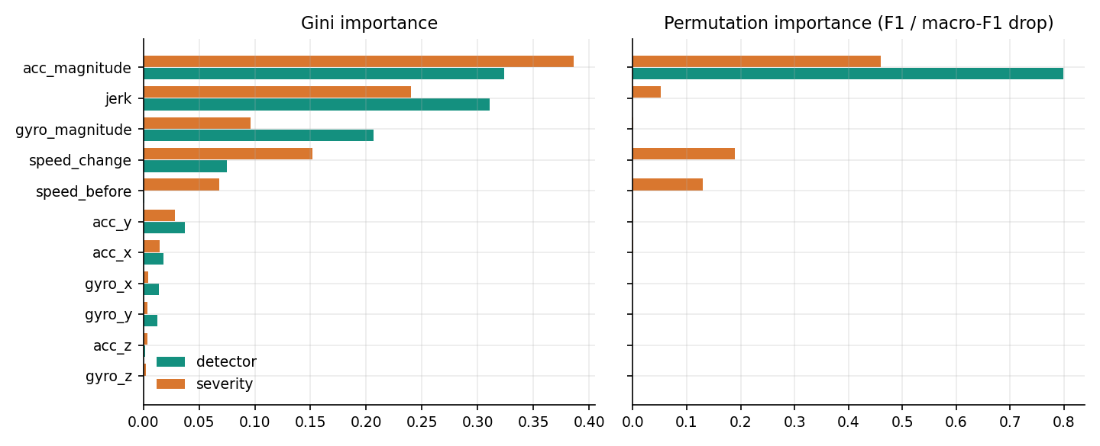
Figure 2: Feature importance of the detector and the severity model: Gini importance (left) and permutation importance (right).
What the models rely on. The Gini importance of the detector is spread over acc_magnitude (0.324), jerk (0.311) and gyro_magnitude (0.206), but permuting any feature other than acc_magnitude leaves the F1 score unchanged (0.798 drop for acc_magnitude, zero for the rest): the other features carry the same information, so the forest can lose them without harm. The severity model uses acc_magnitude (0.459 macro-F1 drop), speed_change (0.189), speed_before (0.130) and jerk (0.051). The gyroscope contributes nothing measurable here, because in the generator the rotation noise does not distinguish the classes beyond what acceleration already does; whether it would on real data is unknown.

2. NOVELTY AGAINST THE BASE PAPER
The base paper named in the batch file is the multi-task FT-Transformer of Wang, Liang and He [1]. It is a model of what happened after a crash: from the police record of 30,442 crashes in one Chinese city, it predicts three severity outcomes (injury, fatality and property loss) with a feature-token transformer, an uncertainty-weighted multi-task loss and SHAP explanations. The survey in the batch file ends with the observation that this whole family of work predicts severity from recorded datasets after the event, and that none of it closes the loop from live sensing through severity grading to automated dispatch [13, 14]. ResQAI is built on that observation, so its novelty lies in the system, not in a new learning algorithm.
Table 7: What is adopted, adapted and new
Element | Base paper | ResQAI | Status
Idea that severity, not only occurrence, should be predicted | Central | Four grades (None, Minor, Moderate, Severe) decide whether anyone is contacted | Adopted
Evaluation by accuracy, precision, recall and F1 | Per task, on 6,088 real test records | Per class on 2,400 synthetic test events, plus five-seed repeat | Adopted
Classifier family | FT-Transformer, multi-task, uncertainty-weighted loss | Two random forests (detector and severity) behind one scaler | Different, standard
Input | Police-recorded driver, vehicle, road and weather attributes | Eleven accelerometer, gyroscope, speed and jerk features of one event | New for this project
Time of use | After the crash, for planning and policy | At the moment of the crash, to trigger a response | New
False-alarm control | Not applicable | 15-second occupant confirmation; only Moderate or Severe starts it | New
Action taken | None (analysis) | Location, three nearest hospitals ranked by distance, drafted dispatch message | New
Interpretability | SHAP at sub-class level | Gini and permutation importance, feature-group ablation | Simpler
Multi-task learning, SMOTE, SHAP | Used | Not used (class weights instead of SMOTE) | Not adopted

2.1 Where the contribution lies
Three things are new relative to the base paper and to the five surveyed works, and each is a matter of design rather than of algorithm. The first is the end-to-end chain: one application takes a motion-sensor reading to a detection, a severity grade, an occupant confirmation, a location, a ranked list of hospitals and a drafted alert, and exposes every step on screen. The second is the confirmation mechanism: the system does not treat its own classification as final, and the choice of which grades start the countdown (Moderate and Severe, not Minor) is explicit and testable. The third is the evaluation, which goes further than the project brief asked: it repeats the experiment over five seeds, compares the forests with simpler models, shows that the detector adds nothing over a threshold on this data while the severity model does, measures the effect of sensor noise, and probes events outside the training distribution. The evaluation exposed limits (the potholes, the noise, the validation gaps) that a single accuracy figure would have hidden.

2.2 What is standard
The classifier is a random forest [21] from scikit-learn [22], the distance is the haversine formula [25], the passwords are hashed with scrypt [27], and the interface is React [28] with a Flask back end. None of these is claimed as new. The labelled data are synthetic and were produced by the project team, so no result of the project is a contribution to the knowledge of how real crashes look in a phone's sensors.
Against GreenBox [6], which also detects an accident and alerts by SMS, ResQAI differs in learning the severity from data instead of fixing hardware thresholds, in keeping a human in the loop through the countdown, and in naming the hospital; GreenBox, in return, runs on real hardware in a moving vehicle and really sends the message. Against CIRS [7], which detects accidents in camera images, ResQAI uses a sensor that every phone carries; CIRS was trained and tested on real frames.

3. KEY CONTRIBUTIONS
The work makes the following contributions. The first five concern the system, the last three the evaluation. Each statement is limited to what the code and the measurements in this report support.
1. An end-to-end, working prototype that turns an 11-feature motion-sensor reading into a crash decision, a four-level severity grade, a 15-second occupant confirmation, a location, three ranked hospitals and a dispatch message, with a React console and a Flask API.
2. A two-model design in which an accident detector gates a severity predictor: when the detector says 'no accident' the severity is forced to None, so a mislabelled severity can never contradict the detection.
3. A confirmation mechanism that starts only for Moderate and Severe results and can be answered by a button or by Escape; cancelling is logged, and live monitoring is paused while a decision is pending.
4. A hospital recommendation step that ranks a directory by great-circle distance from the device position (browser geolocation with a fallback), verified against a brute-force ranking on 500 random positions.
5. A simulator that generates readings from the same parameters as the training data, which lets the whole pipeline be demonstrated and tested without a phone; its consistency with the models is tested (60 of 60 readings per scenario rated correctly).
6. A measured evaluation of the two classifiers on 2,400 held-out events: detector accuracy 1.0000, severity accuracy 0.99958 and macro-F1 0.99866, repeated over five seeds (severity accuracy 0.99875 on average).
7. A comparison with four simpler models, a feature-group ablation and a threshold sweep, which show that a single threshold detects crashes as well as the forest on this data, while the forest grades severity clearly better than the three-threshold rule.
8. A robustness and limits analysis: tolerance to sensor noise up to a tenth of the natural spread, a probe of pothole-like and speed-breaker-like events that the detector flags about half the time, and an input-validation test that found eight gaps in the API.
The code, the generated diagrams, the figures and every measurement script are part of the project folder, so each number in this report can be regenerated with scripts/measure_metrics.py, scripts/measure_api.py and scripts/run_tests.py.

